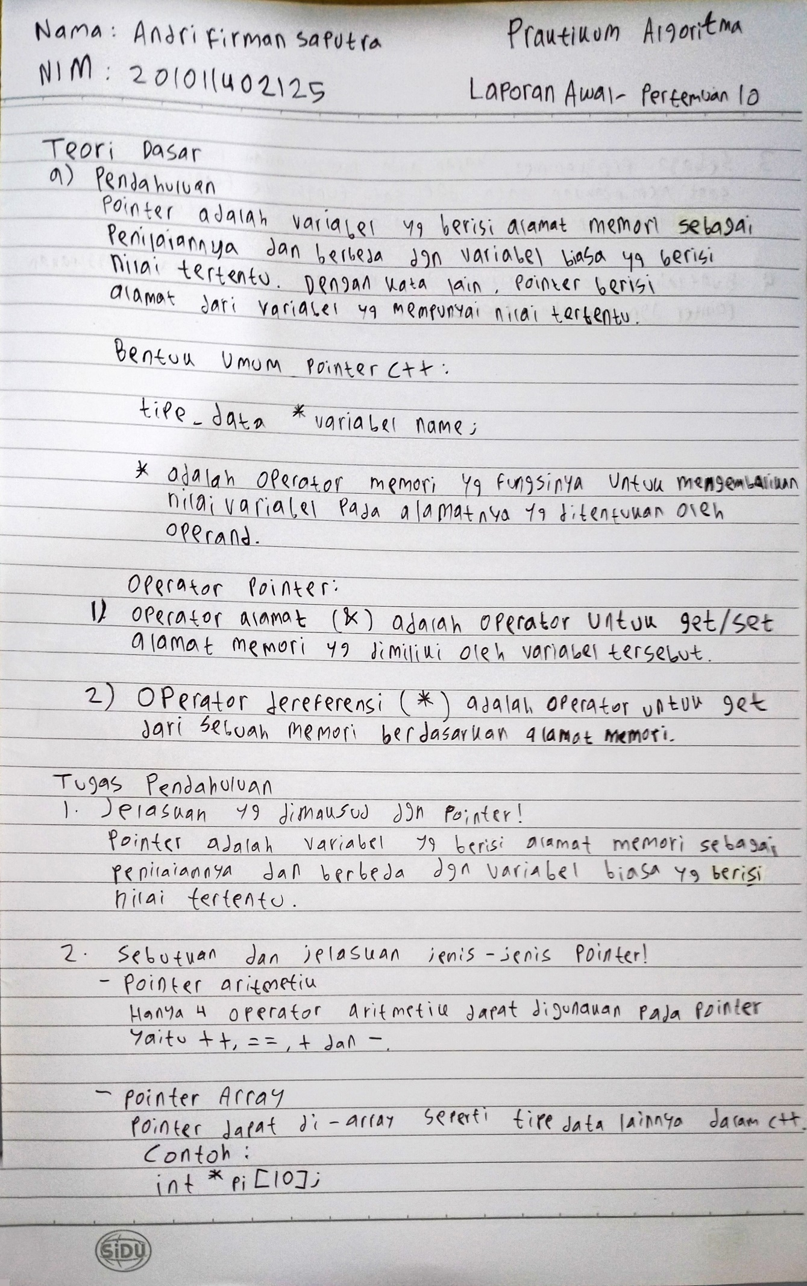

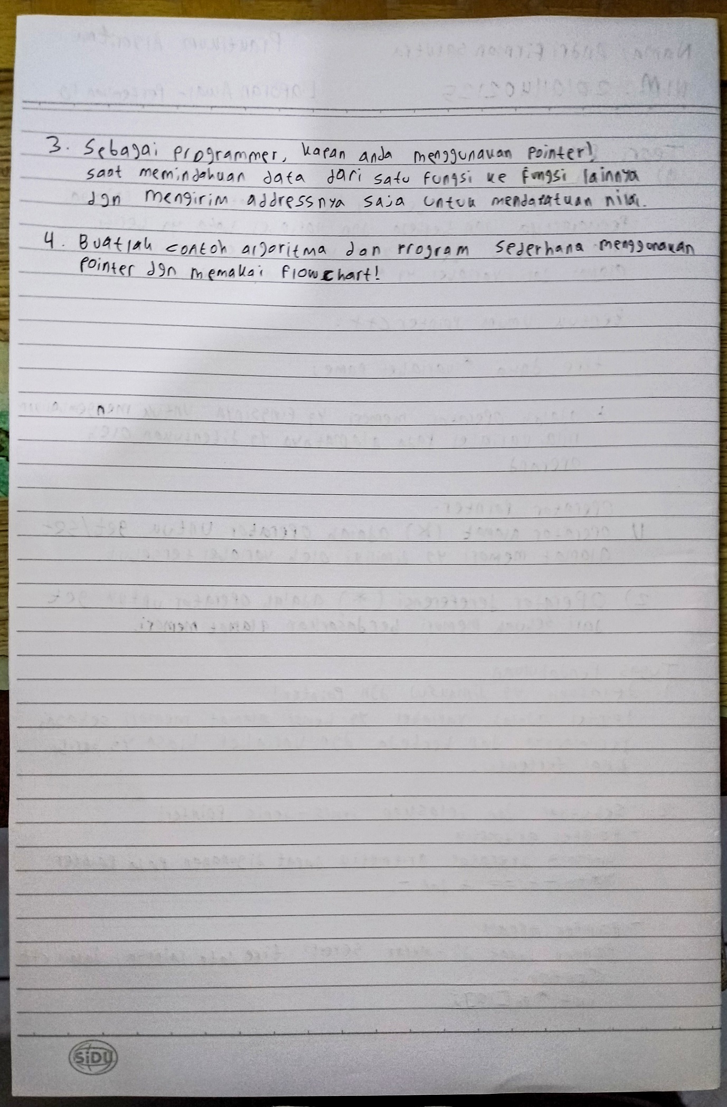

Jawaban No. 4

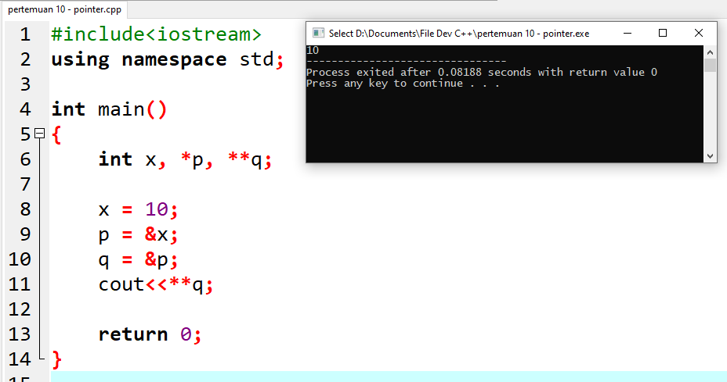

Source Code:

#include<iostream>

using namespace std;

int main()

{

int x, \*p, \*\*q;

x = 10;

p = &x;

q = &p;

cout<<\*\*q;

return 0;

}